 |  | SPRING 2026 NEWSLETTER
 |   Cheswick Green & District u3a    Photo by Roy Holloway   | Contents  - News Update  - Your u3a Needs You  - u3a Trust News  - Member Engagement & Contributions  - Events:  - Christmas Party  - Race Night  - Tips and Resources  - Trivia & Puzzles  - Getting to know our members  - Puzzle answers


CHAIRS REPORT

With the new year now fully embedded, I have been thinking a lot recently about which is my favourite season. I have decided it is Spring. I do love the emerging spring flowers, repaying us for the back breaking planting work done in the Autumn. I love the snow drops - the first sign of better things to come. Then the bursts of colour of the crocuses and the sunshine in the ground of the daffs. The budding of the blossom trees, the lighter nights, the return of sunshine and warmer days. Spring brings hope. (& a birthday!) But gosh, what a cold January and a wet February we have had. We DESERVE the Spring.

This is my last contribution as Chair of our u3a because I have to retire after 3 years, in line with our constitution. (& NO! it can’t be changed 🤣) I only wish retirement also applied to my work life, but I must hang on in there for another 2 years. Don’t get me started on the raised pension age.

It has truly been a privilege to have been the Chair of our u3a and to be able to bring a re- fresh to the way we do some things. But a chair can’t do this alone, and I have had a great committee to work with, and I want to thank each of them who have been with me over the last 3 years. We have had fun while we got the jobs done.

As I look back over the last 3 years, I have realised how much we have achieved. We have created some new groups, introduced the popular after speaker “Chat Café” and introduced the monthly charity raffle. Our monthly meeting attendances increased after the post covid slump and despite recruiting new members being a challenge (for so many reasons, not least the raising of the retirement age - here I go again! 😂), our membership has remained stable. We updated all our tech equipment; we introduced an annual thank you event for the group leaders and on a personal note I brought the laugh and learn from the u3a tag line to the start of our monthly meetings. And so much more.

But I will be stepping down and coming off the committee at the AGM. I have been on the committee for 7 years, 4 as Vice Chair and 3 as Chair. I have helped set up or co-led, at least 10 groups over the years, 3 of which I will still be the named person for. So, it’s time for me to take a break.

Thank you for trusting me to be your Chair. I hope that you will continue to benefit from our u3a, the fun, the learning and the friendships.
I will see you around.

Ruth



u3a TRUST NEWS

u3a Festival 2026

Share your skills at u3a Festival 26

u3a Festival 26 is coming to the University of York from 1-3 July 2026, promising three inspiring days of learning, laughter, and connection. We're looking for members to lead workshops and sessions and we’re especially keen to find performers and leaders for music workshops, along with speakers on both fun and more academic topics. If you have a talent to share or a talk to give, please get in touch at festival@u3a.org.uk.

Online Learning Resources:  The national u3a organisation provides a large number of online webinars on a variety of subjects and can be accessed from this link  : https://www.u3a.org.uk/events/educational-events  Subject Advisors - There are a number of volunteers who have a specialist subject and are available for advice and help. Have a look at this link for more information |  | Digital scams: what to do - Advice from West Mercia Police:  If you think you’re being scammed: Take Five to Stop Fraud  - STOP: Taking a moment to stop and think before parting with your money or information could keep you safe.  - CHALLENGE: Could it be fake? It’s okay to reject, refuse or ignore any requests. Only criminals will try to rush or panic you.  - PROTECT: Contact your bank immediately if you think you’ve fallen for a scam, AND REPORT IT TO ACTION FRAUD  - If you’ve fallen for a scam, report it to Action Fraud on 0300 123 2040 or via actionfraud.police.uk.  - Scam Text messages can be forwarded to 7726 to help phone providers take early action and block numbers that generate spam on their networks. Scam mobile calls can also be forwarded to 7726, followed by the word “CALL”, then the scam phone number  - Forward Fake Emails received to report@phishing.gov.uk  - For further information, see : https://www.actionfraud.police.uk/https://takefive-stopfraud.org.uk/


FAMILY HISTORY GROUP  The group have been exploring our family history for the past ten years and the photos above are of the current group enjoying our Christmas buffet together after our December meeting held at Pat Jackson’s house.  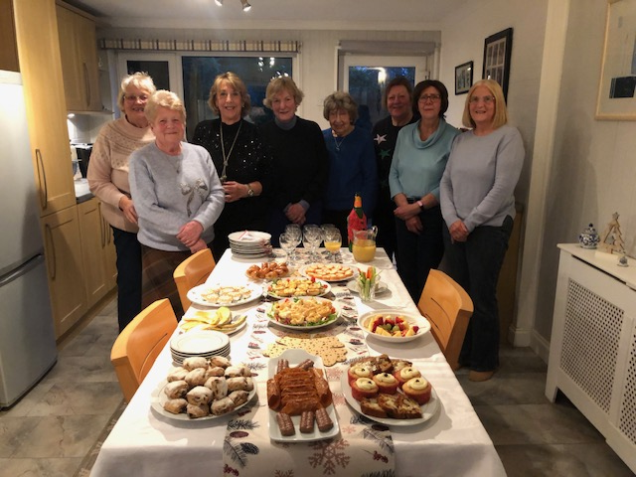  Our subject was ancestral homes. We found that none of us came from landed property, most of our grandparents came from workers cottages etc. and when visiting we were used to outside lavatories, tin baths on walls.  Times have moved on in two generations and central heating, ensuites etc. are now the norm. | DINING OUT GROUP  The Dining Out Group coordinated by Barbara Hancox has been meeting for 10 years now and not yet run out of ideas and places to visit.  Our last meal of 2025 finished the year with a Chinese Festive Buffet in Mappleborough Green.    We explore different types of food each month and have ranged from Thai, Portuguese, Indian, Japanese etc. We are usually a group of 10 people who take turns to nominate a different restaurant, find who is able to attend and then book the meal.  If you would like more information please contact Barbara.  Member Engagement
 |  | .

CORE MEETINGS 2026

DATE | OUTLINE | SPEAKER
19 March | Victorian Magistrate | Alan Cutler
16 April | Solihull Hogs | Alison white
21 May | Birmingham Hospice`
18 June | Songsmith and Other Stories | Andy Smith
16 July | From Poetry to Being Published and the Pitfalls Inbetween | Wendy Westley
20 August | Not Father O’Maley | Roger Browne
17 September | Child Migration | Stephen Dyer
15 October | Dogs for Good
19 November | A Policeman’s Lot | Alan Rogers
17 December | Christmas Party


As a thank you for all the work our Group Leaders do keeping our u3a a fun, friendly and interesting place to be, the committee has invited them all to a CREAM TEA on Thursday 30th April.
If you have an idea for a new group, please contact Hilda our Group Coordinator

CHRISTMAS 2025 PARTY

 | 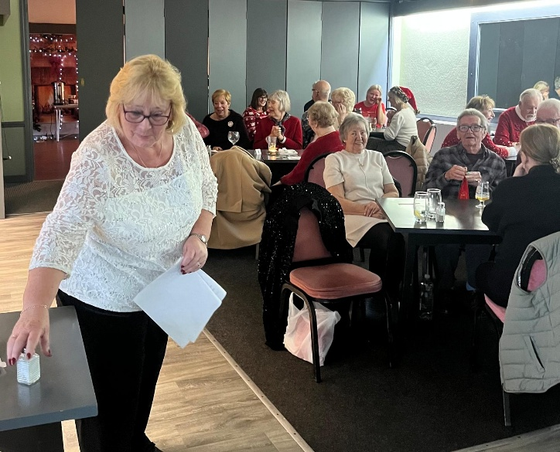
The Ukulele Band | Jacky organising games
 | 
U3a members enjoying the Christmas Party

HOLD THE DATE - THURSDAY 17 DECEMBER 2026
As the Christmas Lunch was so successful, the 2026 Christmas Party will be also held at the Woodbourne Sports Club - further information to follow.

RACE NIGHT FRIDAY 27TH MARCH


The Race Night tickets will be on sale at the Feb and March meetings.
Cost £2. This is a member only, non-refundable event.
FRIDAY 27 MARCH Doors open 7pm.
Where? Cheswick Green Village Hall.
Bring your snacks, drinks and pound coins for your betting money


We have had a really enjoyable evening each time we have run this event so do come and join the fun.

Can’t get to the core meetings? Email Jacky to order your tickets and arrange payment.

 | TIPS & RESOURCES  TRIVIA & PUZZLES | QUIZ (Answers on page 11)  GENERAL KNOWLEDGE  A little bit of everything - flower related and beyond  - Which flower was once more costly than gold and has bulbs which can replace onions in some recipes?  - Which flower inspired the William Wordsworth poem ‘I Wandered Lonely As A Cloud’?  - The largest horticultural campaign in the U.K. is called ‘RHS Britain in…’ what?  - Which flower’s name comes from the Ancient Greek word for star?  - Most species of eucalyptus are native to which country?  - What is Antirrhinum commonly known as, due to the flower’s resemblance to a mythical creature?  - What colour is a Welsh Poppy?  - What is the common name for the blue flower ‘Myosotis’, also known as mouse’s ear?  - Which flower’s colour depends on the amount of acid in the soil?  - In Floriography, what colour rose means ‘Perfect Happiness’  A few exercise jokes  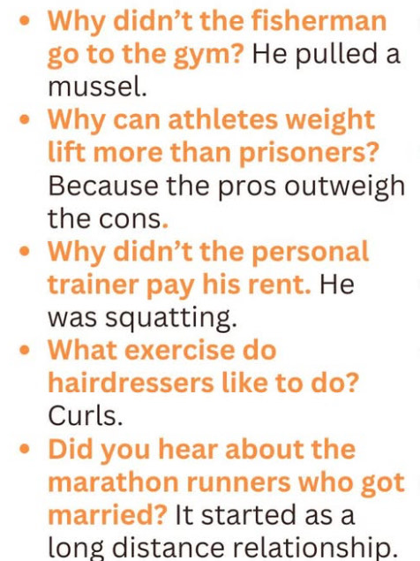
  POWER CUT HELPLINE.
  New research from National Grid Electricity Distribution (NGED) shows that 84% of people in the West Midlands don’t know about the first port of call in a power cut – the 105 helpline.
  105 is a FREE number that connects callers directly to their local electricity network operator in the event of a power cut.
  Power cuts can happen at any time – whether due to severe weather, unexpected incidents, or technical faults.
  For many, the first moments of a power cut can be confusing for people, especially if it’s unclear whether the issue is affecting their home, their street, or the wider area.
  The 105 helpline is designed to provide people with fast, direct access to the right support, regardless of who supplies their electricity.
  National Grid’s support hub at ➡️ https://www.customer.nationalgrid.co.uk/wintersupport provides practical advice on what to do in a power cut
  

Thank you to Richard and Margaret for agreeing to be one of our “Featured Members”

If you would like to contribute to this section, please contact Sue Winwood, Editor

Page 8

Getting to know our Members!

Richard Duffill
HOW DID YOU HEAR ABOUT THE U3A IN THE VILLAGE? My wife Cath heard about U3A from friends in her fitness group.

WHAT YEAR DID YOU JOIN? I think approximately 2012.

YOU ARE CURRENTLY THE NAMED GROUP LEADER FOR THE WINE CLUB. CAN YOU TELL US ABOUT IT.

How Many Members Have You Got?
- The group is called "The Wine Tasting Group". We have 21 members but not everyone can attend every month. If everyone were to turn up, it would make the logistics of obtaining and serving out the wines very difficult and the social interaction would tend to be broken up into smaller groups. However, based on average attendance we probably could accommodate 2 or 3 new members.
When And Where Do You Meet?
- We meet in the Village Hall on the 4th Thursday of the Month, January to November, at 8pm
How Does It Work?
- Each month, a member of the group provides wines according to a particular theme of their choice We have typical supermarket wines and both reds and whites are included at every meeting so that everyone can find something to their taste.
- Initially, the bottles are disguised and small samples of each are tasted and scored. After the identity of the wines has been revealed, the bottles are circulated and shared around the table.
How Do You Choose Wines?
- This is according to each individual's choice of theme for the month. It could be a wine region, grape type, comparison between regions etc.
What Is Your Favourite Wine? No particular favourite

WHAT OTHER GROUPS DO YOU BELONG TO? Curry Club, Book Club, Going Places

Margaret Daniels

A neighbour told me about a new association for retired people which being set up in Cheswick and she thought it might interest me.

This was about 13 years ago. I joined the Family History Group run by the late Hazel Law, as I now had time and help to explore my family tree. Pat Carr and I then set up an Outings Group to arrange visits to interesting places by train, bus and coach hire. The members in the group to contribute and offer suggestions and arrange visits.

Both these groups are still active. I have since joined the Dining Out group run by Barbara Hancox and we arrange monthly meetings across a wide range of different restaurants and food types. I took over from Chris Cox and, with help, arranged to fill coaches for two short holidays to the Isle of Wight and Torquay.

I always enjoy the social events and the opportunity to meet and mix with new people, many who have become good friends.
My career has always been in finance but very varied. I was administrator in a family social work agency in the Charity sector for 23 years before retirement.

I have lived in Cheswick for 43 years; we only moved here temporarily after being gazumped during the purchase of a bungalow on Earlswood Common. We grew to like the village, became involved with our local community and when I recently downsized after the death of my husband, chose to remain within Cheswick and the friends I had found over the past 43 years.

QUIZ ANSWERS
Do you remember this??

GENERAL KNOWLEDGE Flowers

- Tulips
- Daffodil
- Bloom
- Aster
- Australia

- Snapdragon
- Yellow
- Forget-Me-Not
- Hydrangeas
- Pink

Our next Newsletter is the SUMMER EDITION (do we remember sunshine!!??)

If you have any updates and/or photos for inclusion n the next edition, please forward them to suewin2002@gmail.com

